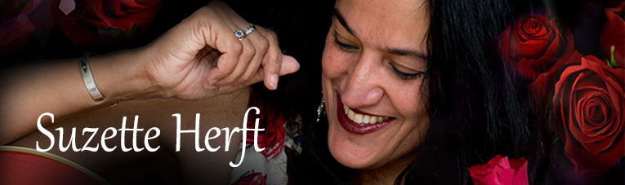
SUZETTE HERFT
P.O. BOX 1146
KENSINGTON, VIC 3031
www.suzetteherft.com
P: +61 3 9372 1740 / 0459 533 523
E: suzette.herft@gmail.com
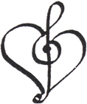

Suzette Herft – Introduction
Suzette Herft has a sublime voice, heartfelt, soulful, original songs, a joyful, sunny countenance and a natural charm and grace to touch your soul.

Suzette Herft – Short Bio
Take some spice from the Isle of Serendip (Sri lanka) and add it to a melting pot of music - folk, country, singer-songwriter troubadours.... Take a spoonful of the purity of the voice of Joan Baez, her passion for giving ‘voice to the voiceless’, the heartbreak in the voice of Emmylou Harris and the soul in the song writing of Patty Griffin, and you've got a taste of the voice and the heart and the soul of the music of Suzette Herft….Soulful, Sublime and Shining!

Suzette Herft – Long Bio
Suzette Herft, is a captivating troubadour and songwriter from the folk/Americana/country traditions. This Sri-Lankan born, but true Melbournian, shines with a natural grace and presence that lights up any stage. "Suzette sings from her soul, she glows when she sings... and every song is plucked with precision from her heart" Mundy (Ireland)

Suzette has won wide acclaim for her brilliant tribute show 'Shining' dedicated to Joan Baez, the ‘voice for the voiceless’ at numerous festivals around Australia, including standing ovations to full houses in past Port Fairy Folk Festivals.

Suzette is a masterful facilitator of singing sessions! She is a ‘song catcher’ with her wide repertoire and is passionate about inclusivity, ‘giving everyone a voice’.

Suzette founded the Melbourne Songwriter Sessions, a workshop session inspired by a visit to Nashville where peers provide critique to bring forth the best in the song.
The title track ‘Planting Roses’ from her 6th album ‘Roses’ (produced by the award winning Shane O’Mara), was a finalist in the Australian Independent Music Awards 2017.

Suzette has 6 cd's including 2 cd’s released in 2015. 'Roses' (an album of original songs produced by Shane O'Mara) and 'Farewell Angelina' - an album of duets with Patrick Evans from the live show of the same title featuring the story of the iconic duo Bob Dylan and Joan Baez.
Don’t miss this captivating songstress who has been described as 'A charismatic singer-songwriter with a heart in tune with her world and a voice to go with it" (The Australian Songwriter).

Suzette Herft – References
‘ A charismatic singer-songwriter with a heart in tune with her world and a voice to go with it.’ The Australian Songwriter
"I met Suzette at Port Fairy folk festival 2017. She sings from her soul and she glows when she's singing. She's at one with her voice. Her choice of covers blows me away. She suffers no duds. Every song she sings is plucked with precision from her heart." Mundy (Ireland)
"Suzette Herft is a talented singer/songwriter whose music has a truly universal appeal for the listeners of my show, ‘Musical Australiana’. They have been generous in their praise of all her works that I have played. Suzette writes beautiful melodies, and her insightful lyrics tell concise stories about the human condition, with great empathy. In her song, “The Heart”, she reveals an incredible rapport with the feelings that our aboriginal folk have for Uluru and the Australian land, especially for one not born here in Australia. Also, her accurate interpretations of songs by Joan Baez and Bob Dylan make them live again, particularly for those of us who heard the originals." Alan Edwards (Musical Australiana) 103.9 Seymour FM
"Joan Baez – quite a challenge to for anyone to create a convincing tribute to her music. Suzette Herft has done just that with her tribute show, "Shining - A Diamond in the Rust", which has won accolades, full rooms and standing ovations at Port Fairy Folk Festival these last two years. Suzette owns the essence of the Baez repertoire with a poise, charm, confidence and ease that carries hapless listeners away on the that dreaming trip when music transcends time and place. This is the gift of a very skilled folk singer." Jamie McKew Former Festival Director-Port Fairy Folk Festival

Suzette Herft is one of Melbourne's most enduring singer songwriters with a passion for great music that sees her constantly mixing familiar classic songs with her own unique originals to ensure audiences are thoroughly satisfied and entertained. Like a great wine she seems to get better and better and even more beautiful with age, and radiates a delightful happy, sunny aura from the stage.
I have twice seen her present her epic yet intimate 'Joan Baez Story' and both times brought a spontaneous longstanding ovation, a fairly rare event at a folk festival. She rations the number of times she performs this show, but I urge any event organiser to twist her arm to add it to their programme. Nobody will be disappointed.
Andrew Pattison The Troubadour, Newstead Live! Former festival director.

Suzette Herft is an amazing singer and performer. She is a true professional and a class act. Her natural style and grace had the audience fully engaged and wanting more. I loved her show and recommend her highly to any festival contemplating booking her. Roger Joseph Arelmedia Management & Arelmusic. Former Artistic Director of Cygnet Folk Festival).

Congratulations, Suzette, on your Joan Baez tribute presentation! It was wonderful to be transported through your singing and narration to that pivotal place & time when songs & social issues were so intertwined (and of course, it doesn't hurt that you resemble the young Joan). Margaret RoadKnight

A hot night, with the stage open to the street, people stopped to listen to the voice and songs of Suzette Herft. Performing classics such as Way over Yonder and the timeless Both Sides Now, along with beautifully crafted originals such as Planting Roses and Cinderella Again, Suzette has the the charm and grace to captivate an audience…..Suzette has a voice that fills a room and songs that can fill your heart! She has a voice that can saturate harmony within any space and instil in all a sense of symmetry and peace in their world….Soaking the depths of place and being..
George Condos – Melbourne Music

Suzette Herft – Presentations / Workshops
Shining – A Diamond in the Rust: A celebration of the life and times of one of the most inspiring and incredible singers in our lifetime. Known as the ‘Madonna’ and the ‘Queen of Hearts’, Joan Baez captured our hearts with her beautiful voice and her strong commitment to non-violence and social justice. Suzette Herft creates a stunning tribute to this great artist who has celebrated more than 60 years of public performance and weaves together the stories and the songs that made this woman a folk- icon and a warrior of the light.
Farewell Angelina; The iconic duo of the 60’s folk era, Joan Baez and Bob Dylan, wowed audiences with their live duets. In 1963, as the reigning ‘Queen of Folk’, Joan’s endorsement of the promising young songwriter played a huge role in Dylan’s early rise to fame. Dylan states “...something told me she was my counterpart, that she was the one my voice would find perfect harmony with…” (Chronicles Vol. 1). Join Suzette Herft and Patrick Evans as they recreate the magic of this iconic folk duo that earned a place in our hearts and psyche and in our musical history.

Bound for Glory; Celebrating the life and the songs of Woody Guthrie, this legendary American Singer-Songwriter who left a legacy of over 1000 songs. 2017 marks the 50 year anniversary of Woody Guthrie's death. 'Bound for Glory' captures the songs, stories and events that not only marked his personal life but also that which influenced his politics and his music. Known as someone who stood with and for the common man, he spoke and sang 'Truth to Power', with one of his songs -'This Land is your Land' becoming the unofficial national anthem. Join Suzette Herft in this story- song celebration of this unassuming folk hero.

Classic Sing-a-long; Sing-a-long to the classic hits of the last few decades, with songs from the voices of Hank Williams, Johnny Cash, The Beatles, Neil Diamond to name a few. Suzette Herft is a seasoned master at facilitating sessions with a vast repertoire. Come along, bring your voices and your instruments, join in and have some fun singing the songs of yester year.

Suzette Herft – Session Reviews
(SINGING SESSIONS) I must thank you very much for the Quiet Man sessions over the last year. You do a fantastic job there every month, very welcoming, entertaining and supportive to all and we only have to look at the number of people there each month to see how popular and enjoyable the nights are. Cheers Bill Field

(SONGWRITER SESSIONS) Thanks to everyone there. It was a great night. I was so impressed by everyone's honesty and the positive, constructive input. It's a very fine balance, and it was struck. Well done Suzette for nurturing this culture. Bruce Watson

Suzette Herft – Cd releases
Suzette’s most recent releases include 'Roses' - a cd of original songs, which received rave reviews for the quality of her song writing, her vocals and the brilliant production by award winning producer and guitarist Shane O'Mara.
Her other recent release is a duo album with musical partner, Patrick Evans from the show of the same name, 'Farewell Angelina' which features the story of the iconic 60’s duo Bob Dylan and Joan Baez in both fascinating story and spine tingling harmony vocals. 'The musical and vocal interplay are just fabulous'
Suzette has released a total of 6 cd's including “Shining – A Diamond in the Rust”- A live concert of the songs from The Joan Baez Tribute show which was launched at Port Fairy Folk Festival in 2014.
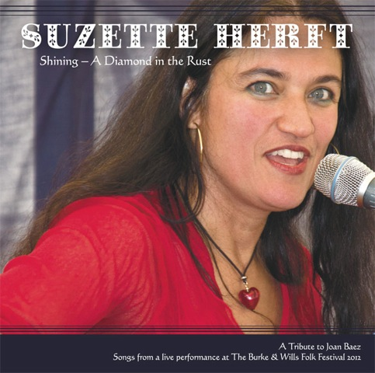
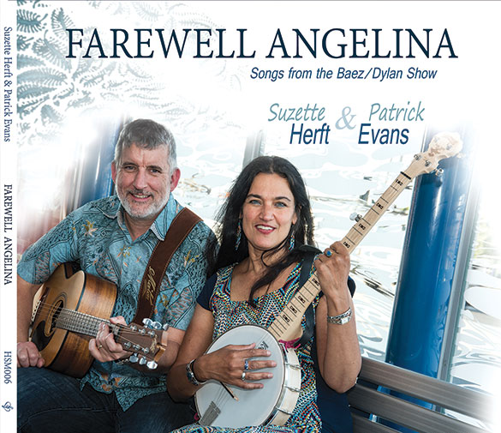
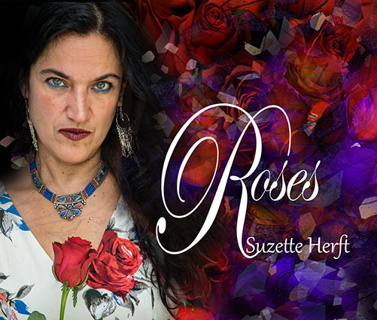

Previous cd’s include ‘Never too Late’, ‘A Place to call Home’ and ‘Both Sides Now’.
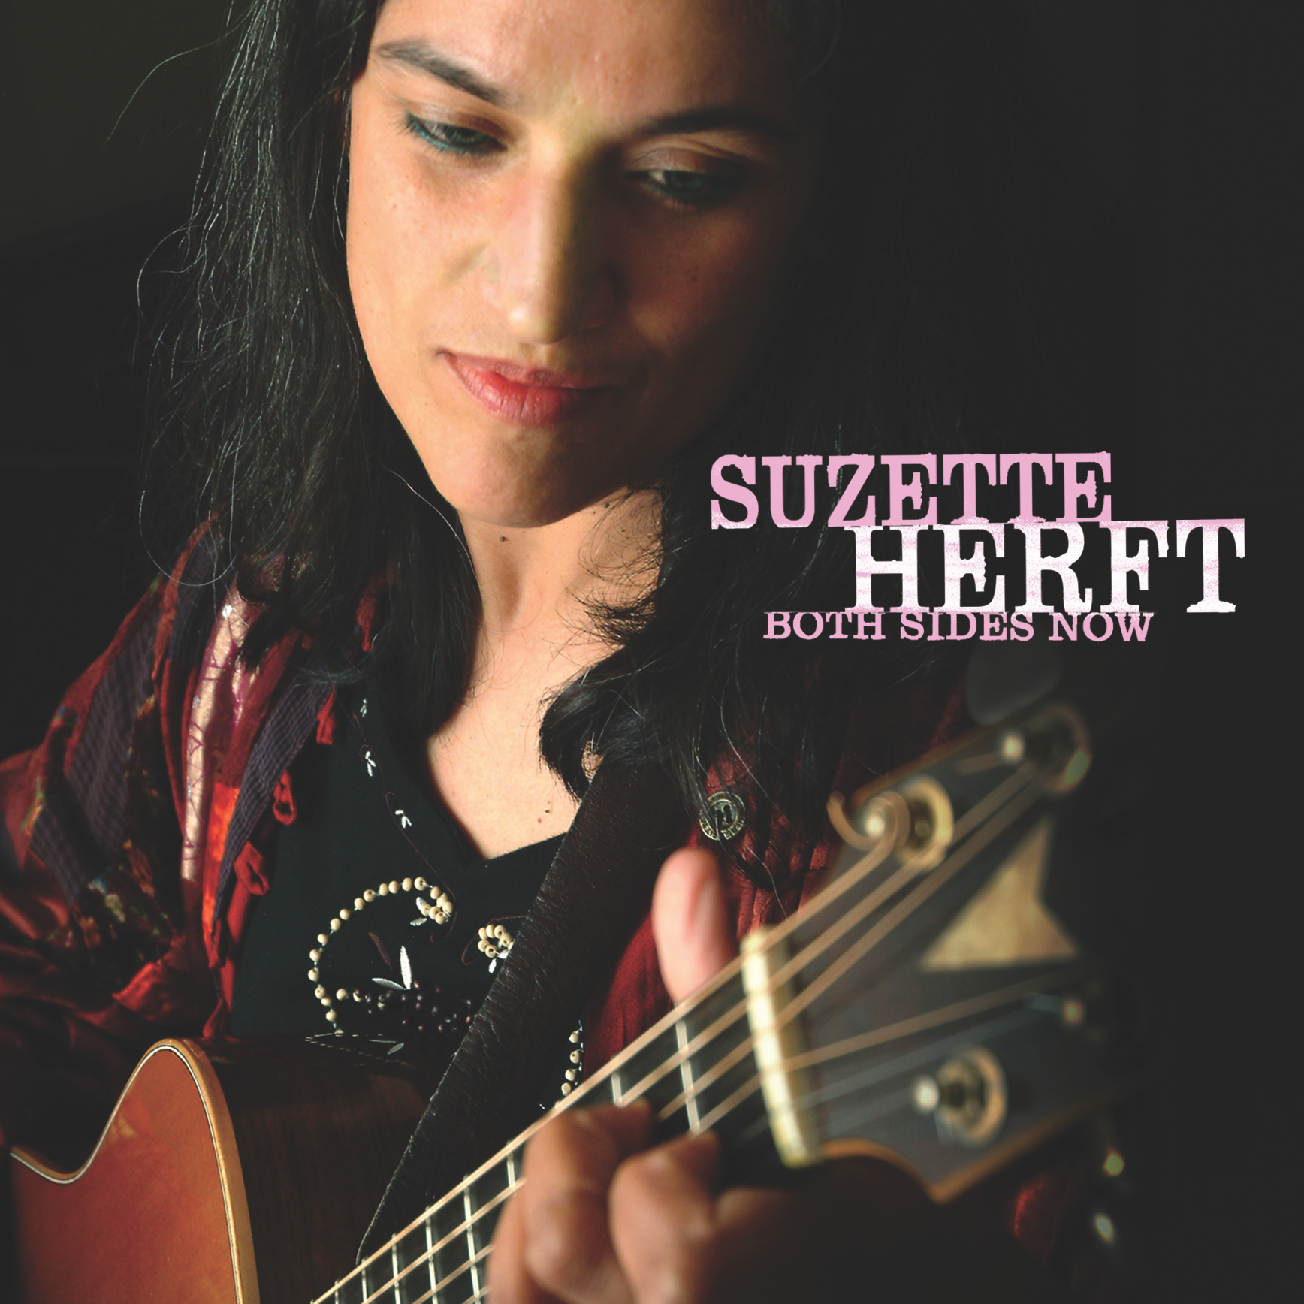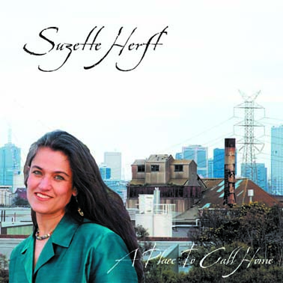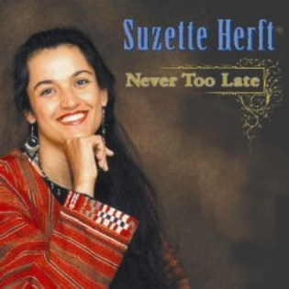

Suzette Herft – Cd reviews
“Roses is the most uplifting, relatable, heartfelt and honest album I've heard in a really long time. Her songwriting beautiful and poetic, you can feel every emotion in her voice because she is singing her truth. My personal favourites - I don't wanna burn, and Planting Roses in which the chorus reaches into my chest and squeezes… Inspirational work Suzette! Jarrod Caspersz

In the tradition of great Americana singer song writers (Patty Griffin, Lucinda Williams, Gillian Welsh and Buddy and Julie Miller, just to name a few) Suzette takes you on a sublime journey of discovery and wonder with songs straight from her heart.
Melting and Melodic, her mellifluous voice is seamless and like a great red wine will warm your heart and soul with her expressiveness and harmonies. “Roses” is irreproachable and sincere in its delivery, a reflection on life itself, warts and all. Inspiring stories of Love, Death, Life and Joy shrouded in vulnerability so palpable that I urge anyone who listens to it not to be moved in some way.
Well done Suzette, “Roses” is a real gem. Martin Gale

NICE WORK on your new album! Shane has done a beautiful piece of work with you. Your voice is brilliant and it's a really strong set of songs. Bill Jackson

‘Roses’ is the 6th album released by Sri Lankan born singer-songwriter Suzette Herft. Her first album featuring only her own beautiful original songs, produced by the talented Shane O’Mara. Shane also added his magic touch via a combination of guitars and other instruments. He was assisted by Patrick Evans (Suzette’s musical partner) on backing vocals and rhythm guitar as well as Ralf Rehak on percussion. With this 6th album Suzette has stepped out of her more ‘folky’ style to get more electric and rootsy. What a treat for us she did! ‘Roses’ is a fine addition to your collection of beautiful women singer-song writers. (Basement Discs)

Suzette Herft - Links
www.suzetteherft.com
https://www.facebook.com/suzetteherft
http://www.youtube.com/user/SuzetteHerft/videos

